**REACT**

**#3**

Create a react app for Student Management Portal named scorecalculatorapp and create a function component named “CalculateScore” which will accept Name, School, Total and goal in order to calculate the average score of a student and display the same.

* **Created a react app for Student Management Portal named scorecalculatorapp**

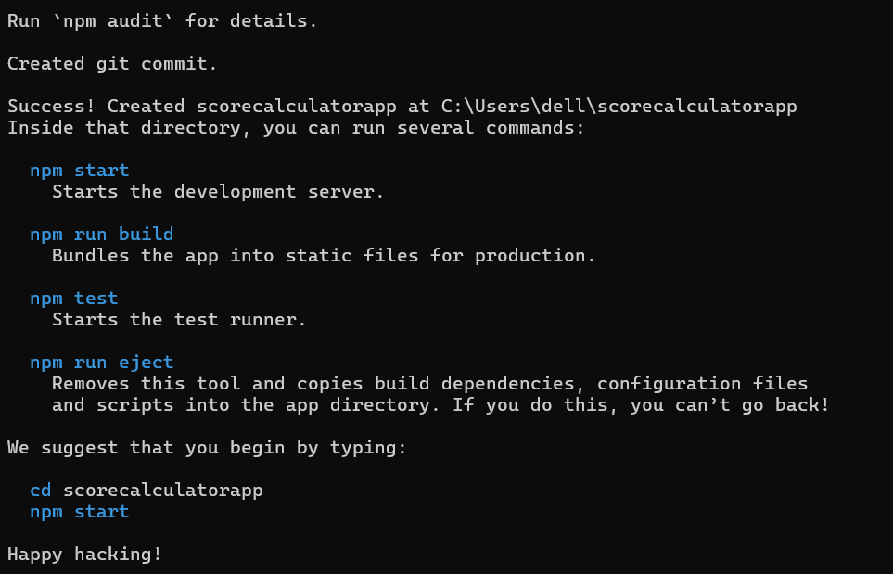

* Created a function component named “CalculateScore” which will accept Name, School, Total and goal

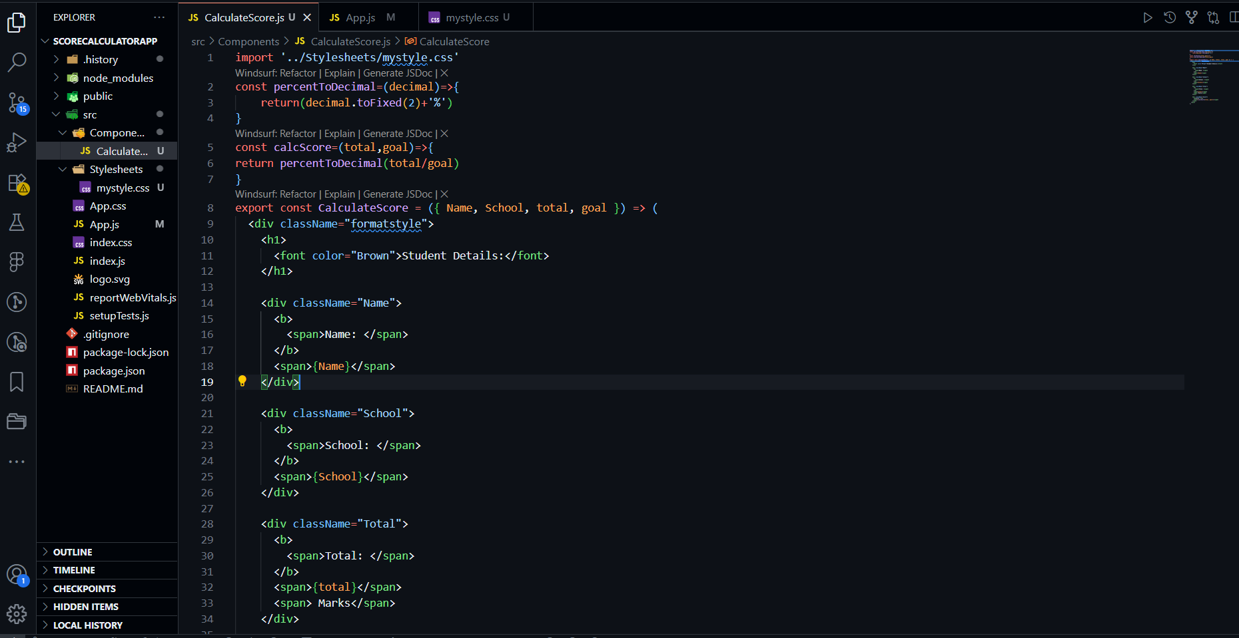

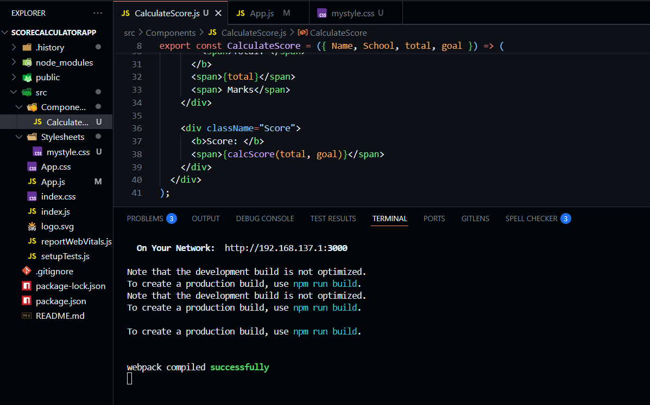

* **Created a Folder named Stylesheets and added a file named “mystyle.css” in order to add some styles to the components:**

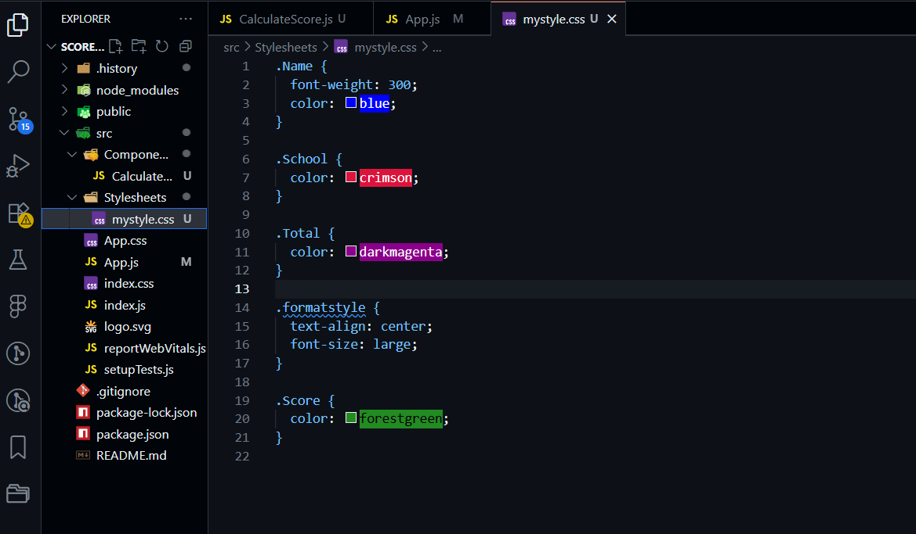

* **Edit the App.js to invoke the CalculateScore functional component**

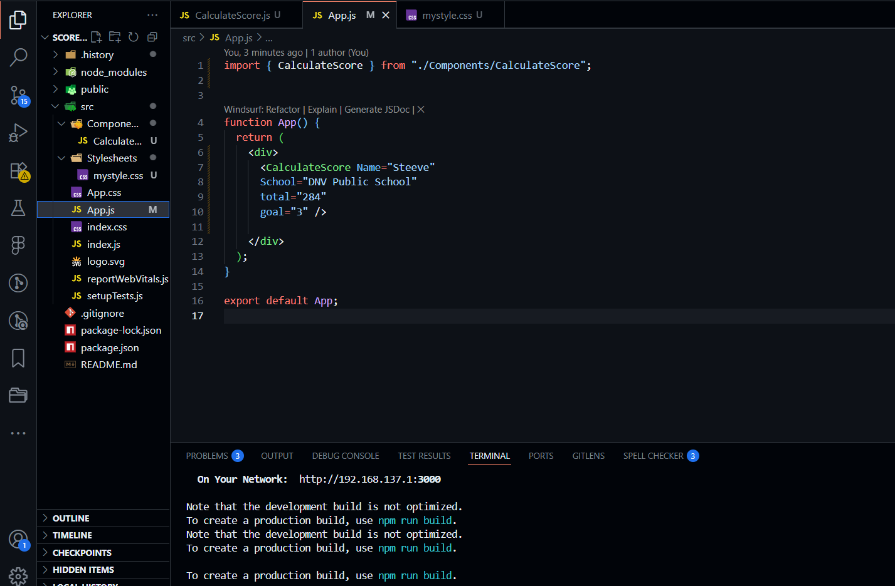

**OUTPUT -**

